Customer Churn Analysis – Credit Card Customers
Objectives: Analyze customer data to identify churn patterns and key behavioral factors.

Tools Used: Python (pandas, matplotlib, seaborn), Jupyter Notebook, Tableau/Power BI

Key Insights:
- Overall churn = 3.4%
- Churn highest for 6–12 month tenure customers (16.4%)
- High utilization (>90%) = most likely to churn
- Low transaction activity = higher churn risk
- 6–12 months + high utilization = highest-risk cluster

Recommendations:
- Focus retention offers on 6–12 month customers
- Credit-limit reviews for customers with >90% utilization
- Encourage more monthly activity via rewards programs

Dataset Overview:
- Dataset: credit_card_customers.csv
- Total records: 1,500
- Total columns: 16
- Key variables: tenure_months (customer age with bank), utilization_ratio (balance / limit), monthly_transactions (activity level), churned (target variable)

Key Metrics:
- Overall churn rate: 3.4%
- Gender churn: F = 2.7%, M = 4.0%
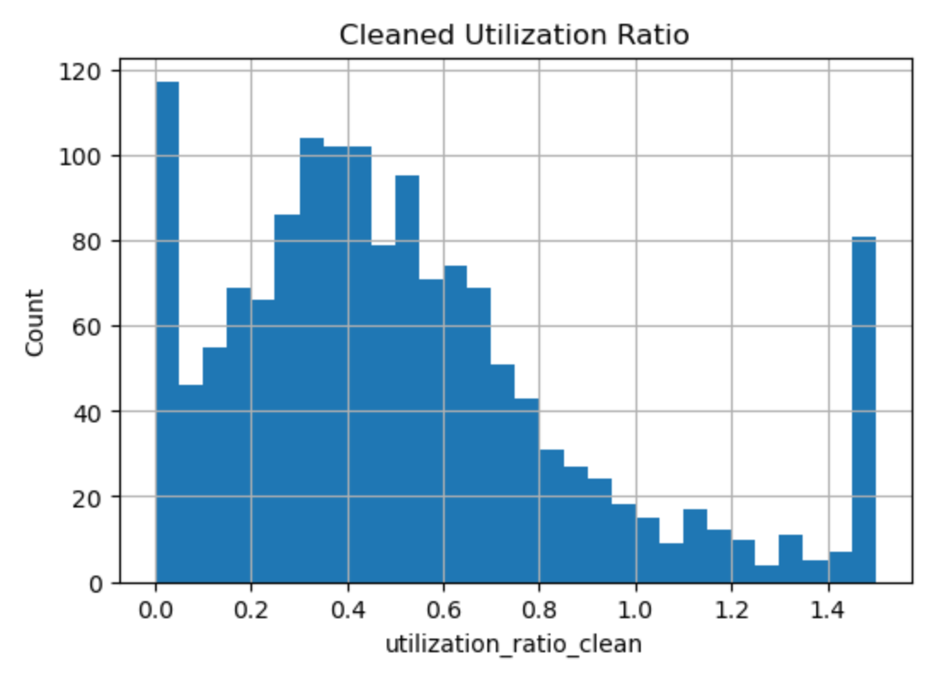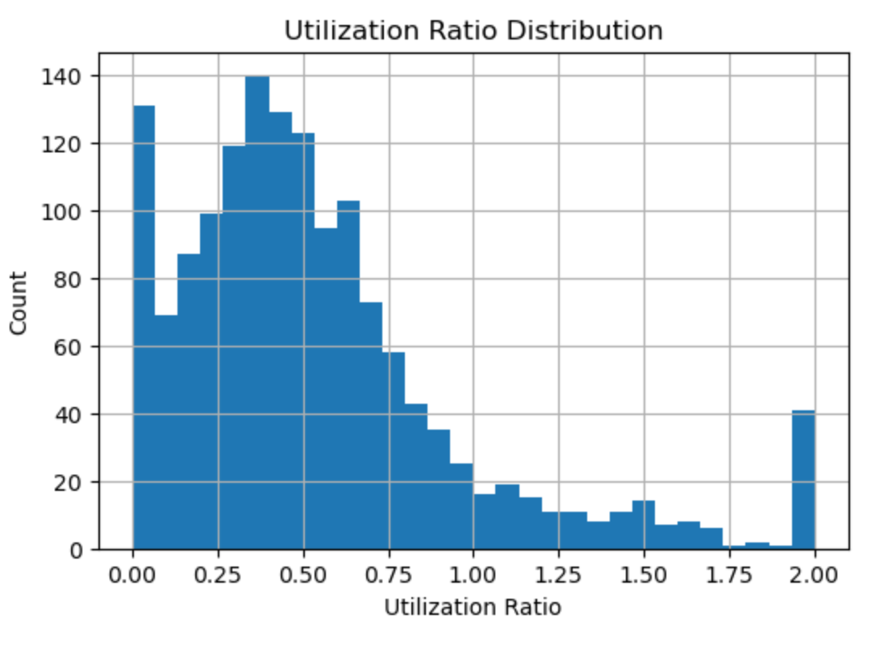

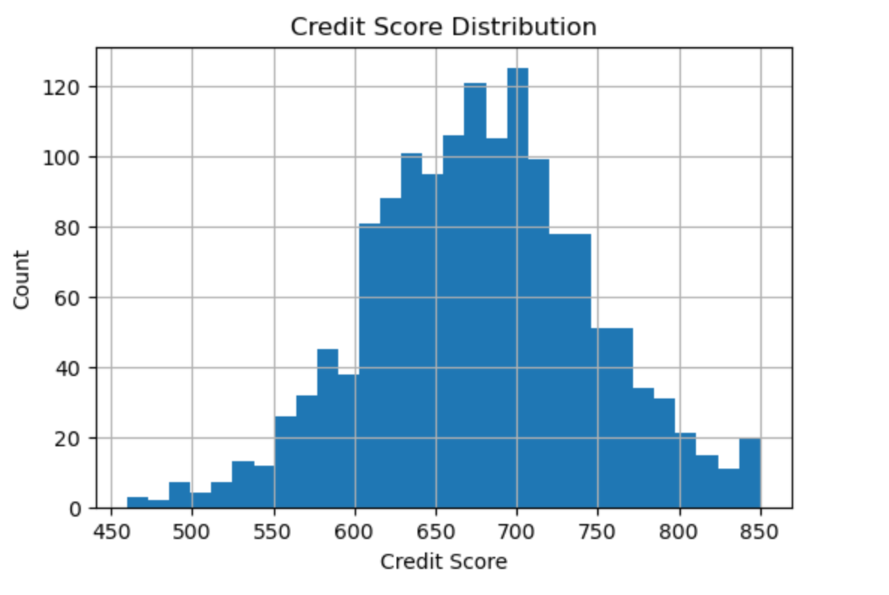

Credit Utilization

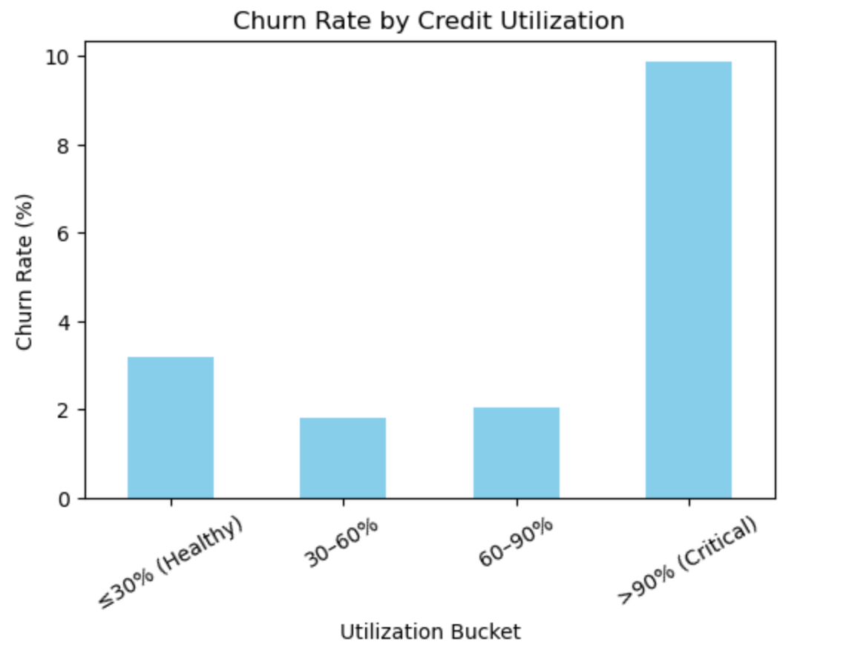
 |  | Interpretation
  Bucket
  Churn %
≤30% (Healthy) | 3.19% | Stable users
30-60% | 1.81% | Lowest churn
60-90% | 2.03% | Moderate risk
>90% (Critical) | 9.86% | Financial stress → churn risk

Customer Tenure
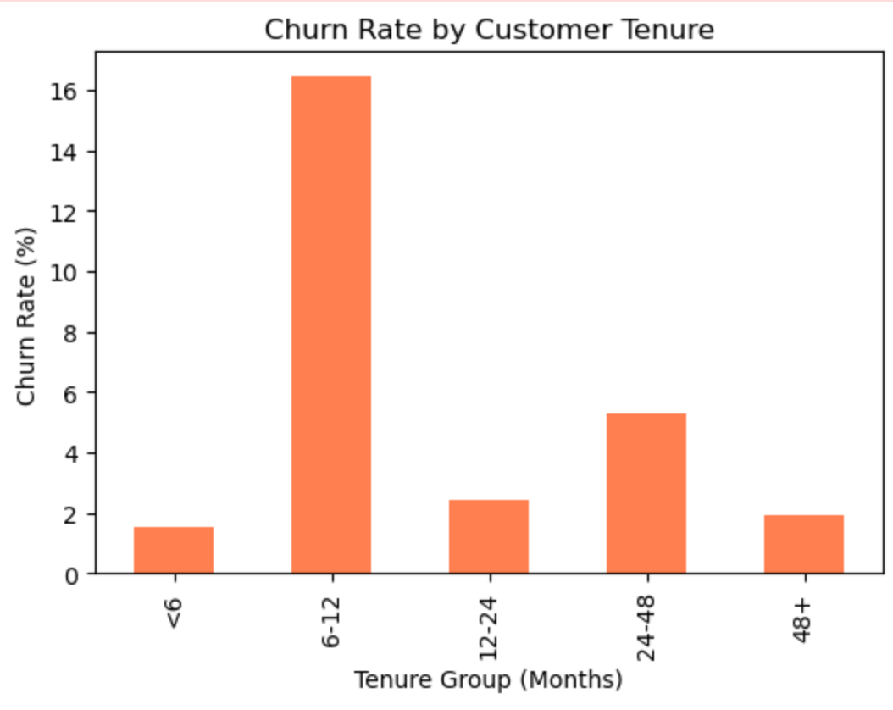
Tenure | Churn % | Interpretation
<6 months | 1.52% | New and stable
6–12 months | 16.44% | Churn peak period
12–24 months | 2.44% | Retention improves
24–48 months | 5.26% | Slight dip
48+ months | 1.95% | Loyal group
Transaction Activity
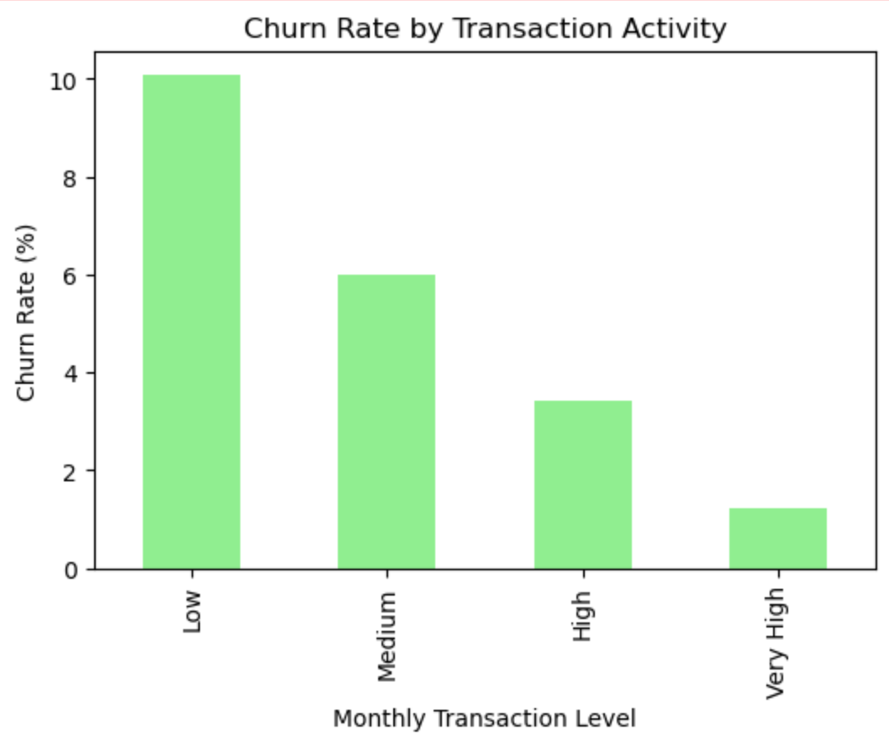
Activity Level | Churn % | Interpretation
Low | 10.07% | Least engaged users
Medium | 6.0% | Moderate churn
High | 3.4% | Retained base
Very High | 1.23% | Loyal / heavy users

Combined Heatmap Insight

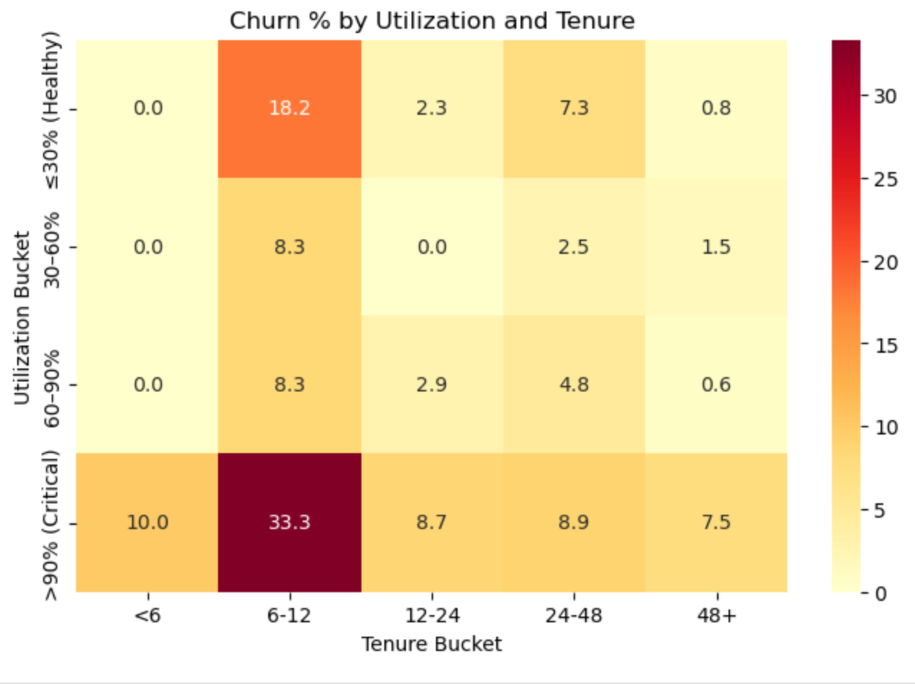
From the heatmap (“Churn % by Utilization and Tenure”):
- Customers with >90% utilization and 6–12 months tenure show the highest churn (33.3%).
This segment should be top priority for retention programs.

Data Cleaning Summary
- Removed duplicates and negative/out-of-range values
- Imputed missing values (median for numeric, “Unknown” for categorical)
- Clipped outliers at 1st–99th percentile
- Created new features:
utilization_ratio_clean, tenure_bucket, util_bucket, tx_bucket

Business Recommendations
- Focus retention campaigns on customers with 6–12 months tenure and >90% utilization
- Offer credit limit reviews or repayment counseling to reduce financial stress
- Encourage monthly activity via cashback or loyalty incentives
- Use predictive modeling to score churn probability

Files Reference
/data/raw/credit_card_customers.csv
/data/processed/credit_card_customers_clean.csv
/notebooks/churn_analysis.ipynb
/dashboard/

